**Summer Internship Report on**

**“Web Development With Python”**

**Submitted by**

**MAHIDA CHINTAN JAYENDRASINH(180760107023)**

**Under the guidance of**

**Prof. Drashti J. Chauhan**

**In partial fulfilment for the award of the degree**

**BACHELOR OF ENGINEERING**

**In**

**COMPUTER ENGINEERING**

|  |  |  |
| --- | --- | --- |
|  | **Shree Swami Atmanand Saraswati Institute of Technology, Surat** |  |

GUJARAT TECHNOLOGICAL UNIVERSITY

**January - April - 2023**

CERTIFICATE

This is to certify that Mahida Chintan Jayendrasinh(180760107023) has successfully completed summer internship(3170001) in Web Development With Python at Tops Technologies from 21 january 2023 to 30 april 2023 and Completed all the activity in PMMS portal under my guidance in partial fulfilment for the degree of Bachelor of Engineering in Computer Engineering Department 8th Semester of Gujarat Technological University, Ahmedabad during the academic year 2022-23

**Date:**

**Place: SSASIT, Surat**

**Prof. Drashti J. Chauhan Prof. Sugandh Gupta**

**Internal Guide Head of the Department**

certificate from gtu pmms

|  |
| --- |
| ) |

**Offer Letter**

**Date: 06/02/2023**

**Name: Mahida Chintan Jayendrasinh**

**Subject: Phython Internship**

Dear **Mahida Chintan jayendrasinh**,

We are pleased to offer you the position of Python Intern at **TOPS Technologies** . This is a valuable opportunity to gain hands-on experience in the field of software development while working on real-world projects. This is a **4 Months** internship program that will commence on **06/02/2023**.

As such your internship will include training/orientation and will be focused primarily on learning and developing new skills and gaining a deeper understanding of concepts through hands-on application off the knowledge you attain in class.

Congratulations again and we look forward to work with you.

Yours Sincerely Best Regards,

Python Team Leader, **Miss Meghna Patel** ,

**Sugandh Gupta**  Co-Founder,

TOPS Technologies

internship completion letter

10

|  |  |  |
| --- | --- | --- |
|  | **Shree Swami Atmanand Saraswati Institute of Technology, Surat** |  |

DECLARATION

We hereby declare that Internship / Project report submitted along with the Internship

Web Development with Python submitted in partial fulfilment for the degree of

Bachelor of Engineering in Computer Engineering to Gujarat Technological

University, Ahmedabad, is a bonafide record of original project work carried out by

at Tops technologies under the supervision of Prof. Drashti J. Chauhan and that no part

of this report has been directly copied from any students report or taken from any other

source, without providing due reference.

Name of the Student Sign of student

**Mahida Chintan Jayendrasinh**

**Date:**

**Place: SSASIT, Surat**

|  |
| --- |
|  |

ACKNOWLEDGMENT

The success of any task relies on the efforts made by person but it cannot be achieved without cooperation of other persons which are being helpful.

So, we would like to thank **SHREE SWAMI ATMANAND SARASWATI INSTITUTE OF TECHNOLOGY** and **Tops technologies** for giving us the opportunity of doing this Summer Internship. The entire session of our internship completion was a great experience providing us with the insight & invocation into learning various software engineering concepts & benefits of team work. We would like to take this opportunity to express our sincere thanks to all those people without whose support and co-operation, it would have been difficult to complete this project.

Primarily, we are very much thankful to our Internship Mentor **Sugandh gupta** and PMMS Internship guide **Prof. Drashti J. Chahuhan** for their leading guidance and sincere efforts throughout project work. They took deep interest in simplifying the difficulties. Also, they have been consistent source of inspiration for us.

We also express thanks to **Prof. Drashti J. Chauhan** class coordinator for her personal involvement, constructive suggestion and thoughtful idea for betterment of the project. We are grateful to our H.O.D. **Prof. Chirag Patel** and our beloved Principal **Prof. Jignesh Vaghasia** for providing us deep knowledge and all necessary resources. We are also thankful to our Friends and Non-teaching Staff for their valuable time & help for completion project. Once again, we are grateful to all those without whom this this work would not have been successful.

|  |
| --- |
|  |

Mahida Chintan Jayendrasinh

.

TABLE OF CONTENTS

ACKNOWLEDGEMENT......................................................................................

ABSTRACT...........................................................................................................

LIST OF FIGURES ..............................................................................................

LIST OF TABLES.................................................................................................

ABSTRACT............................................................................................................

CHAPTER – 1: Overview of Company……………………………………………… 1

* 1. About the Company ………………………………………………………………1

1.2 Work and Services of the Company……………………………………………….2

CHAPTER– 2: Introduction …………………………………………………………..3

2.1 Project Summary ………………………………………………………………….3

2.2 Purpose ……………………………………………………………………………3

2.3 Scope ………………………………………………………………………….......4

2.4 Objective ………………………………………………………………………….5

2.5 Technology ……………………………………………………………………….6

CHAPTER – 3: Python……………………………………………………………..... 7

3.1 Introduction with python…………………………………………………………. 7

3.2 Why python………………………………………………………………………. 9

CHAPTER – 4: Django………………………………………………………………..29

4.1 What is Django?.......................................................................................................29

4.2 How it works ?.........................................................................................................29

4.3 Django installation…………………………………………………………………30

CHAPTER – 5: Coding……………………………………………………………….. 35

5.1 Screenshot of website……………………………………………………………… 37

CHAPTER– 6: Conclusion and Discussion……………………………………………..43

LIST OF TABLES

|  |  |  |  |
| --- | --- | --- | --- |
| product | price | quantity | subtotal |
| tshirt | $25 | 2 | $50 |
| watch | $10 | 5 | $50 |
| apple | $50 | 2 | $100 |
| phone | $100 | 1 | $100 |

**LIST OF FIGURE**

Figure 5.1…………………………………………………………………..37

Figure 5.2…………………………………………………………………..38

Figure 5.3…………………………………………………………………..39

Figure 5.4…………………………………………………………………...40

Figure 5.5……………………………………………………………………41

Figure 5.6…………………………………………………………………….42

ABSTRACT

This project helps the users in curing its disease by giving the list of fruits and herbs that the user should consume in order to get rid of its disease. The main purpose of this project is to help the user to easily search for herbs and fruits that will be good for the health of the user depending on any health issue or disease that he/she is suffering from. This system helps the user to reduce its searching time to a great extent by allowing the user to enter its health problem and search accordingly. The admin can add fruits and herbs to the system and its information. This system also allows the user to view the selected fruit or the herb’s description which describes how the fruit or the herb will help to improve the user’s health. This system also allows the user to place order which will add the items to the user’s cart and make payment for the same. The system also includes a module in which the user can search for the hospitals depending on the name of the disease that it enters. Thus, this system helps to cure the user’s disease to a great extent. System can recommended some product to the user. If different user buy other product then this product should recommended to other active user.

# COMPANY OVERVIEW

**Chapter – 1: Overview of Company**

**Company Name:** Tops Technologies

**Address:** 407 Dhara Arcade Opp Swaminarayan temple, Mahadev Chowk MoTA Varachha Surat 394101 Gujarat,

**Contact No:** +91 73830 23957

**1.1 About Us**

Tops Technologies Is A Company Offering Services In The Field Of Software Development, Website Development, Mobile App Development, Graphic Designing, Digital Marketing, Testing & QA, Bulk SMS & Hosting Provider And IT Consultancy . In Terms Of Services, Designing And Coding. Services Include Customized Software Development, Website Development And Programming, Mobile App Development, Graphic Designing, Digital Marketing, Testing & QA, Bulk SMS & Hosting Provider And IT Consultancy, And Maintenance. Company Has A Vast Experience In Development For Software/Web And Mobile Application. Our Processes Are Highly Streamlined And Proven To Ensure Fastest Delivery Of A High Quality Solution At A Reasonable Cost. We Understand Our Client's Need And Changes Over Period Of Time. We Have Expertise To Accommodate Changes At Any Stage Of Software Lifecycle

**1.2 Our Work Is Our Identity**

We Provide A Wide Range Of Web Solutions Such As Professional Website Design And Development, Customized Software Development, Website Development And Programming, Mobile App Development, Graphic Designing, Digital Marketing, Testing & QA, Bulk SMS & Hosting Provider And IT Consultancy To A Wide Range Of Clients. We Give Our First Priority To Our Client Satisfaction. We Solve Any Query Of Our Customer With Appropriate Explainations And Also Adopt Their Ideas After Proper Discussions. We Are Available At Any Time According To Our Clients Requirement. We Do Our Best To Fulfill The Requirement Of Our Clients. We Deliver Our Product On Time And To Specification. We Accurately Follow The Best And Usual Web Developing Life Cycle Which Is: Planning, Analysis, Design, Implementing And Review.

**Why Choose Us?**

Tops Technologies is a company in offering services in the field of Software development, Website Development, Mobile Application Development and Customized ERP Solutions.

**Chapter – 2: Introduction**

**2.1 Project Summary**

The health management system project would involve designing and developing a comprehensive software platform that can be used by healthcare providers to manage and store patient data securely. The system should be able to handle a wide range of medical data, including patient demographics, medical histories, diagnoses, treatments, lab results, and medication records.

**2.2 Purpose**

The purpose of the health management system project is to develop a comprehensive software platform that can improve the quality of healthcare by providing healthcare providers with easy and secure access to electronic health records (EHRs) and other medical data.

The health management system project aims to address some of the challenges that healthcare providers face when managing patient data, including:

Inefficient data management: Healthcare providers often struggle to manage the large volumes of patient data generated in the course of providing care. The health management system can help to streamline data management by providing a centralized platform for storing and accessing patient records.

Medical errors: Medical errors can occur when healthcare providers do not have access to complete and accurate patient information. The health management system can help to reduce the risk of medical errors by providing up-to-date and accurate information on patient histories, diagnoses, treatments, and medications.

Data security and privacy: Patient data must be stored and managed securely to comply with regulations and protect patient privacy. The health management system can help to ensure data security and privacy by implementing robust security protocols and access controls.

Fragmented care: When patient data is stored in disparate systems or paper records, it can be difficult to provide coordinated care across different healthcare providers and settings. The health management system can help to facilitate coordinated care by providing a centralized platform for sharing patient data among healthcare providers.

The scope of the health management system project is to design and develop a comprehensive software platform that can manage and store electronic health records (EHRs) and other medical data securely. The system should be scalable and customizable to meet the unique needs of healthcare providers in different settings.

**2.3 Scope**

**Electronic health records (EHRs) management: The system should allow healthcare providers to create, store, and manage patient health records securely. It should be able to capture patient demographics, medical histories, diagnoses, treatments, lab results, and medication records.**

**Patient scheduling and appointment management: The system should allow healthcare providers to schedule appointments, manage patient waitlists, and send appointment reminders.**

**Clinical decision support tools: The system should provide healthcare providers with access to clinical decision support tools to help them make informed decisions about patient care.**

**Secure messaging and communication tools: The system should provide secure messaging and communication tools to facilitate collaboration among healthcare providers and patients.**

**Prescription management and drug interaction checking: The system should allow healthcare providers to manage prescriptions and check for potential drug interactions.**

**Lab test result management: The system should allow healthcare providers to manage and store lab test results and share them with patients and other healthcare providers.**

**Billing and payment processing: The system should allow healthcare providers to manage billing and payment processing efficiently.**

**Reporting and analytics tools: The system should provide healthcare providers with reporting and analytics tools to help them track patient outcomes and improve care delivery.**

**2.4 Objective**

**Improve patient care: The health management system aims to improve patient care by providing healthcare providers with easy and secure access to electronic health records (EHRs) and other medical data. This will help healthcare providers to make informed decisions about patient care, reduce the risk of medical errors, and improve patient outcomes.**

**Streamline healthcare operations: The health management system aims to streamline healthcare operations by providing a centralized platform for storing and managing patient data. This will help to reduce inefficiencies in data management, improve communication and collaboration among healthcare providers, and reduce administrative burdens.**

**Enhance data security and privacy: The health management system aims to enhance data security and privacy by implementing robust security protocols and access controls to protect patient information. This will help to comply with regulations and protect patient privacy.**

**Increase accessibility: The health management system aims to increase accessibility to patient data by providing healthcare providers with easy and secure access to patient records. This will help to improve care coordination across different healthcare providers and settings.**

**Day 1: Basic Introduction To Python-Language**

# CHAPTER3

# 3.1 Introduction with Python

* Python is an interpreted, object-oriented, high-level programming language with dynamic semantics.
* Its high-level built in data structures, combined with dynamic typing and dynamic binding, make it very attractive for Rapid Application Development.
* Python supports modules and packages, which encourages program modularity and code reuse.
* The Python interpreter and the extensive standard library are available in source or binary form without charge for all major platforms, and can be freely distributed.

# 

# 3.1 Why Python?

* **Designed to be easy to learn and master**
* Clean, clear syntax
* Very few keywords
* **Highly portable**
* Runs almost anywhere - high end servers and workstations, down to windows CE
* Uses machine independent byte-code
* **Extensible**
* Designed to be extensible using C/C++,
* allowing access to many external libraries

# Features of Python

* **Clean syntax plus high-level data types**
* Leads to fast coding (First language in many universities abroad!)
* **Uses white-space to delimit blocks**
* Humans generally do, so why not the language?
* Try it, you will end up liking it
* **Variables do not need declaration**
* Although not a type-less language

# 

# Python Productivity

* **Reduced development time**
* code is 2-10x shorter than C, C++, Java
* **Improved program maintenance**
* code is extremely readable
* **Less training**
* language is very easy to learn

# 

# OOPS in Python

* Python has been an object-oriented language since it existed. Because of this, creating and using classes and objects are downright easy.
* Overview of OOP Terminology
* **Class:** A user-defined prototype for an object that defines a set of attributes that characterize any object of the class. The attributes are data members (class variables and instance variables) and methods, accessed via dot notation.
* **Class variable:** A variable that is shared by all instances of a class. Class variables are defined within a class but outside any of the class's methods. Class variables are not used as frequently as instance variables are.
* **Data member:** A class variable or instance variable that holds data associated with a class and its objects.
* **Function overloading:** The assignment of more than one behavior to a particular function. The operation performed varies by the types of objects or arguments involved.
* **Instance variable:** A variable that is defined inside a method and belongs only to the current instance of a class.
* **Inheritance:** The transfer of the characteristics of a class to other classes that are derived from it.
* **Instance:** An individual object of a certain class. An object obj that belongs to a class Circle, for example, is an instance of the class Circle.
* **Instantiation:** The creation of an instance of a class.
* **Method:** A special kind of function that is defined in a class definition.
* **Object:** A unique instance of a data structure that's defined by its class. An object comprises both data members (class variables and instance variables) and methods.
* **Operator overloading:** The assignment of more than one function to a particular operator.

**Programming Style**

* Python programs/modules are written as text files with traditionally a .py extension.
* Each Python module has its own discrete namespace.
* Name space within a Python module is a global one.
* Python modules and programs are differentiated only by the way they are called. • .py files executed directly are programs (often referred to as scripts) • .py files referenced via the import statement are modules.
* Thus, the same .py file can be a program/script, or a module.

# Core python concepts

# Conditional Statements

# o If o If- else o Nested if-else

* Decision making is anticipation of conditions occurring while execution of the program and specifying actions taken according to the conditions.
* Decision structures evaluate multiple expressions which produce TRUE or FALSE as outcome.
* **If statement** o It is similar to that of other languages.

o The if statement contains a logical expression using which data is compared and a decision is made based on the result of the comparison. • Syntax: if expression:

Statement

* **If Example:**

a=10 if a>0:

print(“A Is Positive Number”)

**If…else Statement**

* It is frequently the case that you want one thing to happen when a condition it true, and something else to happen when it is false.
* For that we have the if else statement.
* **Syntax :** if expression:

Statement else: Statement

* **If….else Example**

|  |
| --- |
| a=10 if a>0:  print(“A Is Positive Number”) else:  print(“A Is Negative Number”) |

**Nested if...else Statement**

* There may be a situation when you want to check for another condition after a condition resolves to true.
* In such a situation, you can use the nested if construct
* **Syntax :** if expression1:

Statement if expression2: Statement else: Statement

* **Nested if example:**

|  |  |
| --- | --- |
| a=10 b=20 c=30 if a>b: | if a>c:  print(“A Is Greater”) else:  print(“C Is Greater”) |
| else: | if b>c:  print(“B Is Greater”) else:  print(“C Is Greater”) |

# Looping

* A loop statement allows us to execute a statement or group of statements multiple times.
* Python programming language provides following types of loops to handle looping requirements.
* While Loop
* For Loop

**For loop** has the ability to iterate over the items of any sequence, such as a list or a string.

* **Syntax :** for iterating_var in sequence:

Statements(s)

* If a sequence contains an expression list, it is evaluated first.

Then, the first item in the sequence is assigned to the iterating variable *iterating_var*.

* Next, the statements block is executed.
* Each item in the list is assigned to *iterating_var*, and the statement(s) block is executed until the entire sequence is exhausted
* **For Example**

i=1

for i in range(1, 10):  if i<=5:

print(i, *“Smaller Than Equal Than 5"*)  else:

print(i, *“Larger Than 5"*)

**While**

* A **while** loop statement in Python programming language repeatedly executes a target statement as long as a given condition is true.  Syntax : while expression:  Statement
* Here, statement(s) may be a single statement or a block of statements. The condition may be any expression, and true is any non-zero value. The loop iterates while the condition is true.

|  |
| --- |
| number=23 running=True    while running:  guess=int (input (*"Enter An Integer : "*)) if guess==number: print (*"Success"*) running=False elif guess<number:  print (*"Lower Than Original"*) elif guess>number:  print (*"Higher Than Original"*) else: print (*"Sorry"*) else: print(*"The While Loop Is Over"*) print (*"Done"*) |

**Nested loops**

* Python programming language allows to use one loop inside another loop. Following section shows few examples to illustrate the concept.
* Syntax :For for iterating_var in sequence: for iterating_var in sequence:

Statements(s) statements(s)

Note: The range () Function

* If you do need to iterate over a sequence of numbers, the built-in function range() comes in handy.
* It generates Arithmetic progressions.

for i in range (1, 7):

for j in range (i):

print(i, end=*' '*) print ()

* Syntax : while while expression:

while expression:

Statement

Statement

Nested While Example:

**Control Statements**

* Loop control statements change execution from its normal sequence.
* When execution leaves a scope, all automatic objects that were created in that scope are destroyed.
* Python supports the following control statements.
* Break
* Continue
* P

|  |
| --- |
| i=0;j=0 a while i<7:  s  j=0 while j<i:s  print(i, end=*' '*)  j=j+1  i=i+1  print() |

**Break statement:**

* It brings control out of the loop and transfers execution to the statement immediately following the loop.

for l in *"Tops Technology"*: if l==*‘p’ or* l==*'s'*: break

print (*"Current Letter: "*, l)

**Continue Statement :**

* It continues with the next iteration of the loop

for l in *"Tops Technology"*: if l==*‘p’ or* l==*'s'*: continue print (*"Current Letter: "*, l)

**Pass Statement:**

* The pass statement does nothing.
* It can be used when a statement is required syntactically but the program requires no action.  For example:

for l in *"Tops Technology"*: pass

print(*"Current Letter: "*, l)

# String Manipulation:

* Textual data in Python is handled with ”str” objects, or *strings*. Strings are immutable(fixed/rigid) sequences of Unicode code points.
* String literals are written in a variety of ways:
* Single quotes: 'allows embedded "double" quotes'  Double quotes: "allows embedded 'single' quotes".
* Triple quoted: '''Three single quotes''', """Three double quotes"""
* Triple quoted strings may span multiple lines - all associated whitespace will be included in the string literal.

# String functions

* **str.capitalize()**
* Return a copy of the string with its first character capitalized and the rest lowercased.
* **str.casefold()**
* Return a case folded copy of the string. Case folded strings may be used for caseless matching.
* **str.center(*width*[, *fillchar*])**
* Return centered in a string of length *width*. Padding is done using the specified *fillchar* (default is an ASCII space). The original string is returned if*width* is less than or equal to len(s).
* **str.count(*sub*[, *start*[, *end*]])**
* Return the number of non-overlapping occurrences of substring *sub* in the range [*start*, *end*].
* Optional arguments *start* and *end* are interpreted as in slice notation.
* **str.endswith(*suffix*[, *start*[, *end*]])**
* Return True if the string ends with the specified *suffix*, otherwise return False.
* *Suffix* can also be a tuple of suffixes to look for.
* With optional *start*, test beginning at that position.
* With optional *end*, stop comparing at that position.
* **str.find(*sub*[, *start*[, *end*]])**
* Return the lowest index in the string where substring *sub* is found within the slice s [start: end].
* Optional arguments *start* and *end* are interpreted as in slice notation.

Return -1 if *sub* is not found.

**Note:**

* The find () method should be used only if you need to know the position of *sub*. To check if *sub* is a substring or not, use the ”in”operator:
* >>>**>>>** 'Py' **in** 'Python' True
* **str.format(*\*args*, *\*\*kwargs*)**
* Perform a string formatting operation. The string on which this method is called can contain literal text or replacement fields delimited by braces{}.
* Each replacement field contains either the numeric index of a positional argument, or the name of a keyword argument. Returns a copy of the string where each replacement field is replaced with the string value of the corresponding argument.
* str.index (*sub* [, *start* [, *end*]]) Like find (), but raise Value Error when the substring is not found.
* **str.isalnum()**
* Return true if all characters in the string are alphanumeric and there is at least one character, false otherwise.
* A character c is alphanumeric if one of the following returns True:
* **c.isalpha(), c.isdecimal(), c.isdigit(), or c.isnumeric().**
* **str.isidentifier()**
* Return true if the string is a valid identifier according to the language definition  **str.islower()**
* Return true if all cased characters in the string are lowercase and there is at least one cased character, false otherwise.
* **str.istitle()**
* Return true if the string is a titlecased string and there is at least one character, for example uppercase characters may only follow uncased characters and lowercase characters only cased ones. Return false otherwise.
* **str.isupper()**
* Return true if all cased characters in the string are uppercase and there is at least one cased character, false otherwise.
* **str.join(*iterable*)**
* Return a string which is the concatenation of the strings in the iterable. A TypeError will be raised if there are any non-string values in*iterable*, including bytes objects. The separator between elements is the string providing this method.
* **str.ljust(*width*[, *fillchar*])**
* Return the string left justified in a string of length *width*. Padding is done using the specified *fillchar* (default is an ASCII space). The original string is returned if *width* is less than or equal to len(s).
* **str.lower()**
* Return a copy of the string with all the cased characters converted to lowercase.
* **str.partition(*sep*)**
* Split the string at the first occurrence of *sep*, and return a 3-tuple containing the part before the separator, the separator itself, and the part after the separator.
* If the separator is not found, return a 3-tuple containing the string itself, followed by two empty strings.
* **str.replace(*old*, *new*[, *count*])**
* Return a copy of the string with all occurrences of substring *old* replaced by *new*.
* If the optional argument *count* is given, only the first countoccurrences are replaced.
* **str.split(*sep=None*, *maxsplit=-1*)**

Return a list of the words in the string, using *sep* as the delimiter string. If *maxsplit* is given, at most *maxsplit* splits are done (thus, the list will have at most maxsplit+1 elements).

* If *maxsplit* is not specified or -1, then there is no limit on the number of splits  **str.swapcase()**
* Return a copy of the string with uppercase characters converted to lowercase and vice versa.
* **str.title()**
* Return a titlecased version of the string where words start with an uppercase character and the remaining characters are lowercase.

# Functions

|  |  |  |
| --- | --- | --- |
| **Name** | | **Description** |
| **len(list)** | | **Gives the total length of the list.** |
| **max(list)** | | **Returns item from the list with max value.** |
| **min(list)** | | **Returns item from the list with min value.** |
| **list(seq)** | | **Converts a tuple into list.** |
| **Methods** | | **Description** | | |
| **list.append(x)** | | **Add an item to the end of the list. Equivalent to a**  **[len(a):]=[x].** | | |
| **list.extend(L)** | | **Appends the contents of L to list** | | |
| **list.insert(I,x)** | | **Insert an item at a given position. The first argument is the index of the element before which to insert, so a.insert(0,x) inserts at the front of the list,and a.insert(len(a),x) is equivalent to a.append(x).** | | |
| **list.count(obj)** | | **Returns count of how many times obj occurs in list** | | |
| **list.index(obj)** | | **Returns the lowest index in list that obj appears** | | |
| **List.pop(obj=list[-1]** | | **Removes and returns last object or obj from list.** | | |
| **List.reverse()** | | **Reverses Objects of list in place** | | |
| **List.sort([fun])** | | **Sorts objects of list, use compare function If given** | | |
| **List.remove(obj)** | | **Removes object obj from list** | | |

# Dictionaries

* Introduction
* Accessing values in dictionaries
* Working with dictionaries
* Properties
* Functions

### o Introduction

* Dictionaries are sometimes found in other languages as “associative memories” or “associative arrays”.
* Unlike sequences, which are indexed by a range of numbers, dictionaries are indexed by *keys*, which can be any immutable type; strings and numbers can always be keys.
* Tuples can be used as keys if they contain only strings, numbers, or tuples; if a tuple contains any mutable object either directly or indirectly, it cannot be used as a key.
* You can’t use lists as keys, since lists can be modified in place using index assignments, slice assignments, or methods like append() and extend().
* The main operations on a dictionary are storing a value with some key and extracting the value given the key.
* Like lists they can be easily changed, can be shrunk and grown ad libitum at run time. They shrink and grow without the necessity of making copies. Dictionaries can be contained in lists and vice versa.
* A list is an ordered sequence of objects, whereas dictionaries are unordered sets.
* But the main difference is that items in dictionaries are accessed via keys and not via their position.

### o Methods and Functions  Methods

|  |  |
| --- | --- |
| **dist.copy()** | **A dictionary can be copied with the method copy():.** |
| dist.update() | It merges the keys and values of one dictionary into another, overwriting values of the same key. |
| dist.values() | It returns the list of dictionary dict’s values. |
| dist.keys() | It returns the list of dictionary dict’s keys. |
| dist.items() | It returns the list of dictionary dict’s keys,values in tuple pairs. |
| dist.clear() | Removes all elements of dictionary dict. |

**Defining a function**

* Python gives us many built-in functions like print(), etc. but we can also create our own functions.
* A function in Python is defined by a def statement. The general syntax looks like this:

def function-name(Parameter list): Statements, i.e. the function body

return [expression]

* The keyword ”def” introduces a function *definition.*
* It must be followed by the function name and the parenthesized list of formal parameters. The statements that form the body of the function start at the next line, and must be indented.
* The ”return” statement returns with a value from a function.”return” without an expression argument returns None.
* Falling off the end of a function also returns None.
* Example:

def checkNoEvenOdd(x): if x % 2 == 0: print(x, "is even") else:

print(x, "is odd")

* Calling a function
* Once function define, we can call it directly or in any other function also.
* Eg. checkNoEvenOdd(20)
* Output: 20 is even  Types of functions

|  |  |
| --- | --- |
| **Functions can be of** |  |
| Built-in functions | Functions that come built into the Python language itself are called built-in functions and are readily available to us. Eg: input(),eval(),print() etc… |
| User defined functions | Functions that we define ourselves to do certain specific task are referred as user-defined functions.  Eg:checkNoEvenOdd(20) |

* Function Arguments
* It is possible to define functions with a variable number of arguments.
* The function arguments can be
* Default arguments values
* Keyword arguments
* ArbitraryArgumentLists
* **Default arguments values**
* The most useful form is to specify a default value for one or more arguments.
* This creates a function that can be called with fewer arguments than it is defined to allow.  Eg. def employeeDetails(name,gender=’male’,age=35)  This function can be called in several ways:
* giving only the mandatory argument : employeeDetails(“Ramesh”)
* giving one of the optional arguments: employeeDetails(“Ramesh”,’Female’)
* or even giving all arguments : employeeDetails(“Ramesh”,’Female’,31)
* Note : The default value is evaluated only once. This makes a difference when the default is

a mutable object such as a list, dictionary, or instances of most classes. For example, the following function accumulates the arguments passed to it on subsequent calls:

* If you don’t want the default to be shared between subsequent calls, you can write the function like this instead: def f(a, L=None): if L is None: L = [] L.append(a)

return L

* **Keyword Arguments**
* Functions can also be called using keyword arguments of the form kwarg=value.
* For instance, the following function:
* def parrot(voltage, state='a stiff', action='voom', type='Norwegian Blue'):
* accepts one required argument (voltage) and three optional arguments (state, action, and type).
* **ArbitraryArgumentLists**
* These arguments will be wrapped up in a tuple . Before the variable number of arguments, zero or more normal arguments may occur.
* Eg : def write_multiple_items(file, separator, *args):

file.write(separator.join(args))

* Normally, these variadic arguments will be last in the list of formal parameters, because they scoop up all remaining input arguments that are passed to the function.
* Any formal parameters which occur after the *args parameter are ‘keyword-only’ arguments, meaning that they can only be used as keywords rather than positional arguments. def concat(*args, sep="/"):

return sep.join(args)

* concat("earth", "mars", "venus") O/P->'earth/mars/venus‘
* concat("earth", "mars", "venus", sep=".") O/P->'earth.mars.venus'

def testFunction(firstArg,secondArg,thridArg,*args,**kwargs):

for k in kwargs:

# print(k,kwargs[k]) RegularExpression

* match function
* Search function
* Matching Vs Searching

#  Modifiers

* Patterns
* Regular expressions (called REs,or regexes,or regexpatterns)are essentially a tiny , highly specialized programming language embedded inside Python and made available through the re module.
* Regular expression patterns are compiled into a series of bytecodes.
* The regular expression language is relatively small and restricted, so not all possible string processing tasks can be done using regular expressions.
* Since regular expressions are used to operate on strings, we’ll begin with the most common task: matching characters.
* **Match function**
* This function determines if the RE matches at the beginning of the string.
* Syntax
* re.match(pattern,string, flags=0)
* pattern :This is the regular expression to be matched.
* string :This is the string, which would be searched to match the pattern at the beginning of string.
* flags :You can specify different flags using bitwise OR (|).
* **Search function:**
* Scan through a string, looking for any location where this RE matches.
* Syntax :re.search(pattern,string, flags=0)
* pattern :This is the regular expression to be matched.
* string :This is the string, which would be searched to match the pattern anywhere in the string.
* flags :You can specify different flags using bitwise OR (|).
* Match vs search
* a pattern. But search attempts this at all possible starting points in the string. Match just tries the first starting point.
* **Modifiers :**
* Regular expression literals may include an optional modifier to control various aspects of matching. The modifiers are specified as an optional flag. You can provide multiple modifiers using exclusive OR (|).

|  |  |
| --- | --- |
|  |  |
| **Modifier** | **Description** |
| re.I :IGNORECASE, | Perform case-insensitive matching; character class and literal strings will match letters by ignoring case. For example, [A-Z]will match lowercase letters, too, and Spam will match Spam, spam, or spAM. |
| re.L LOCALE |  |
| re.M :MULTILINE, | Multi-line matching, affecting ^ and $. When this flag is specified, ^ matches at the beginning of the string and at the beginning of each line within the string, immediately following each newline. Similarly, the $metacharacter matches either at the end of the string and at the end of each line |
| re.A ASCII | Make \w, \W, \b, \B, \s and \S perform ASCII-only matching instead of full Unicode matching. This is only meaningful for Unicode patterns, and is ignored for byte patterns. |
| re.S DOTALL | Makes the ’.’ special character match any character at all, including a newline; without this flag, ’.’ will match anything except a newline. |
| re.XVERBOSE | When this flag has been specified, whitespace within the RE string is ignored, except when the whitespace is in a character class or preceded by an unescaped backslash; this lets you organize and indent the RE more clearly. |

# Patterns

 Except for control characters, **(+ ? . * ^ $ ( ) [ ] { } | \)**, all characters match themselves. You can escape a control character by preceding it with a backslash.

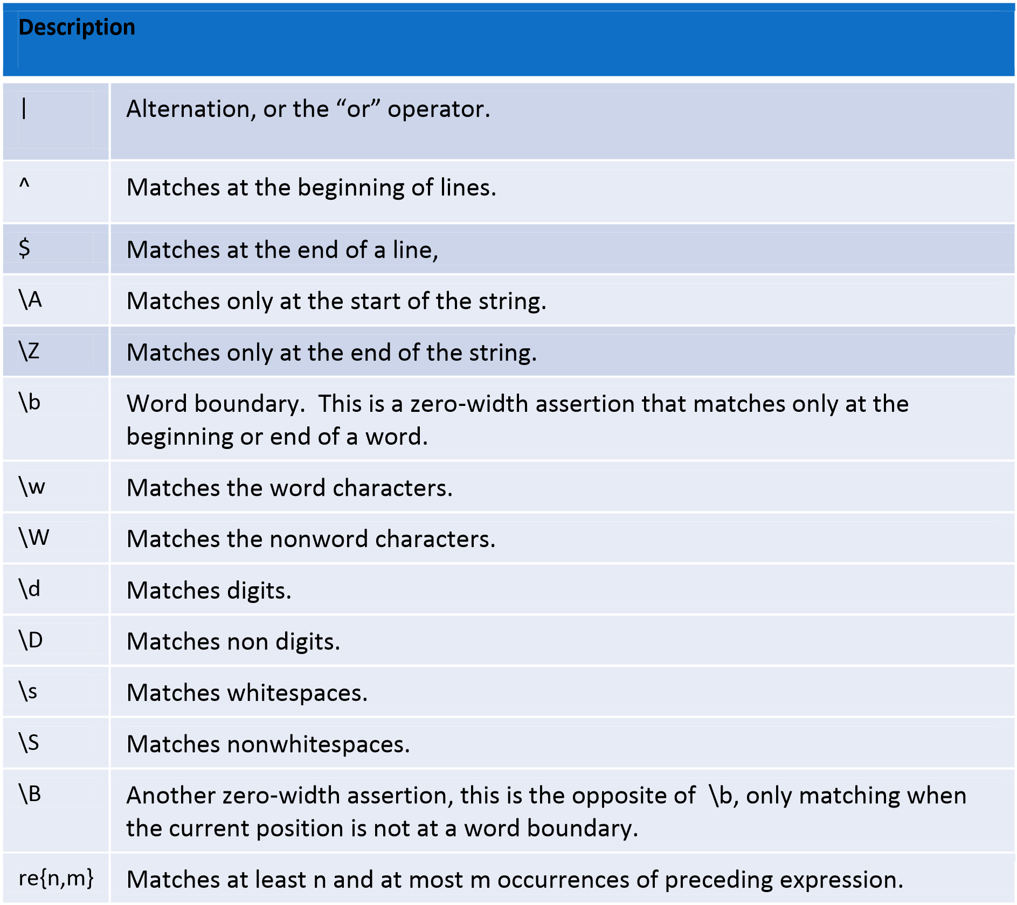

# Architecture

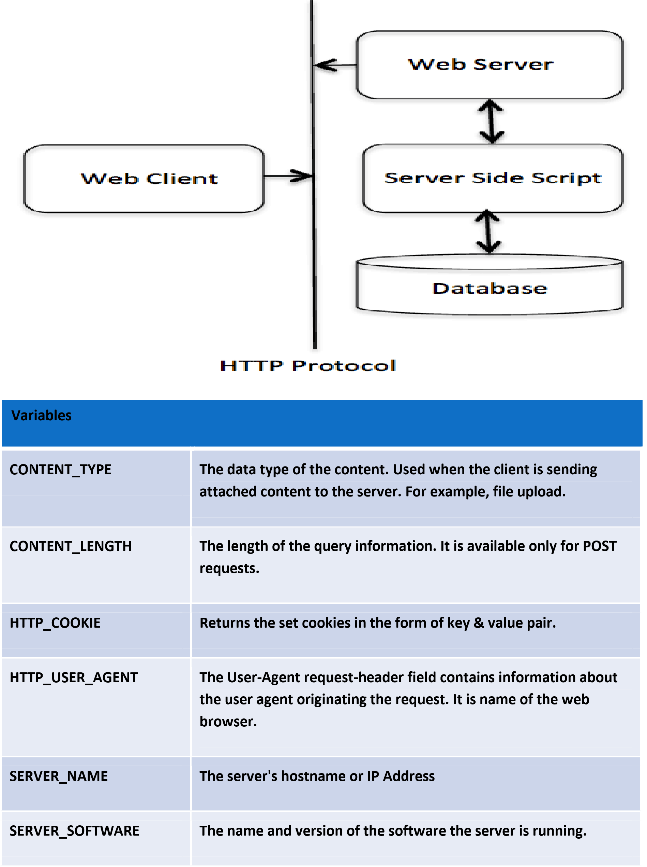

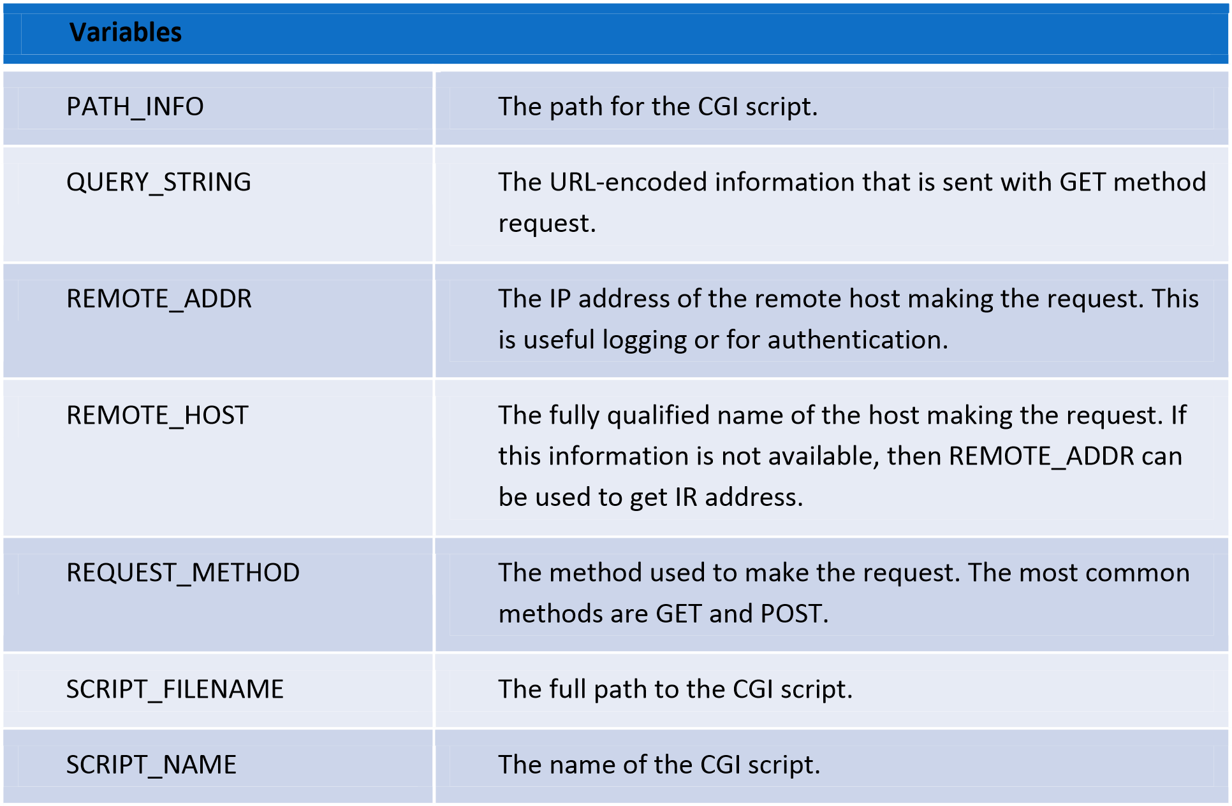

# Get And Post Methods

* Browser uses two methods two pass this information to web server. These methods are GET Method and POST Method.
* The GET method sends the encoded user information appended to the page request.

The page and the encoded information are separated by the ? Character like o <http://www.xyz.com/cgi-bin/hello.py?key1=value1&key2=value2>o The GET method is the default method to pass information from browser to web server.

* Never use GET method if you have password or other sensitive information to pass to the server.
* The GET method has size limtation: only 1024 characters can be sent in a request string.
* The GET method sends information using QUERY_STRING header and will be accessible in your CGI Program through QUERY_STRING environment variable.

• **Post method**

* A generally more reliable method of passing information to a CGI program is the POST method.
* This packages the information in exactly the same way as GET methods, but instead of sending it as a text string after a ? in the URL it sends it as a separate message.
* This message comes into the CGI script in the form of the standard input. o

# Cookies

* HTTP protocol is a stateless protocol.
* For a commercial website, it is required to maintain session information among different pages.

For example, one user registration ends after completing many pages.

* In many situations, using cookies is the most efficient method of remembering and tracking preferences, purchases, commissions, and other information required for better visitor experience or site statistics.

• **How It Works?**

* **Your server sends some data to the visitor's browser in the form of a cookie.** o **The browser may accept the cookie.** o If it does, it is stored as a plain text record on the visitor's hard drive.
* Now, when the visitor arrives at another page on your site, the cookie is available for retrieval.
* Cookies are a plain text data record of 5 variable-length fields:
* Expires: The date the cookie will expire. If this is blank, the cookie will expire when the visitor quits the browser.
* Domain: The domain name of your site.
* Path: The path to the directory or web page that sets the cookie. This may be blank if you want to retrieve the cookie from any directory or page.
* Secure: If this field contains the word "secure", then the cookie may only be retrieved with a secure server. If this field is blank, no such restriction exists.
* Name=Value: Cookies are set and retrieved in the form of key and value pairs. o Setting the cookies is done as :
* print(“Set-Cookie:UserId=xyz;\r\n”) o print(“Set-Cookie:Password=xyzPass;\r\n”) o print(“Set-Cookie:Expires=Saturday,22-Sep-2000 23:12:22 GMT;\r\n”) o Retrieving the cookies if environ.has_key('HTTP_COOKIE'): for cookie in map(strip, split(environ['HTTP_COOKIE'], ';')):

(key, value ) = split(cookie, '='); if key == "UserID": user_id = value if key == "Password": password = value

# File Upload

• To upload a file, the HTML form must have the enctype attribute set to multipart/form-data. The input tag with the file type creates a "Browse" button.

<html>

<body>

<form enctype="multipart/form-data"

action="save_file.py" method="post"> <p>File: <input type="file" name="filename" /></p>

<p><input type="submit" value="Upload" /></p>

</form>

</body>

</html>

**Example**

# MultiThreading

* Thread
  + A Thread or a Thread of Execution is defined in computer science as the smallest unit that can be scheduled in an operating system.
  + Threads are usually contained in processes.
  + More than one thread can exist within the same process.
  + Every process has at least one thread, i.e. the process itself.
  + A process can start multiple threads.
* Starting A Thread
  + There are two modules which support the usage of threads in Python:
  + thread
  + &
  + threading
  + It's possible to execute functions in a separate thread with the module Thread.
  + To do this, we can use the function thread.start_new_thread:
  + thread.start_new_thread(function, args[, kwargs]) ▪ This method starts a new thread and return its identifier.
  + The method call returns immediately and the child thread starts and calls function with the passed list of *agrs*. When function returns, the thread terminates.
  + Here, *args* is a tuple of arguments; use an empty tuple to call function without passing any arguments. *kwargs* is an optional dictionary of keyword arguments.

Example

* Threading Module
  + The **threading** module constructs higher-level threading interfaces on top of the lower level **_thread** module.
  + Creating Thread using threading module.
  + Define a new subclass of the *Thread* class.
  + Override the *__init__(self [,args])* method to add additional arguments.
  + Then, override the run(self [,args]) method to implement what the thread should do when started.
  + Once you have created the new *Thread* subclass, you can create an instance of it and then start a new thread by invoking the *start()*, which in turn calls *run()*method.
  + The *threading* module exposes all the methods of the *thread* module and provides some additional methods:

|  |  |
| --- | --- |
|  | |
| **Method** | **Description** |
| threading.activeCount(): | Returns the number of thread objects that are active. |
| threading.currentThread(): | Returns the number of thread objects in the caller's thread control. |
| threading.enumerate(): | Returns a list of all thread objects that are currently active. |

The threading module has the *Thread* class that implements threading. The methods provided by the *Thread* class are as follows:

|  |  |
| --- | --- |
|  |  |
| Method | Description |
|  | |
| run(): | The run() method is the entry point for a thread. |
| start(): | The start() method starts a thread by calling the run method. |
| join([time]): | The join() waits for threads to terminate. |
| isAlive(): | The isAlive() method checks whether a thread is still executing. |
| getName(): | The getName() method returns the name of a thread. |
| setName(): | The setName() method sets the name of a thread. |

# 

# CHAPTER 4 Django

# 4.1 What is Django?

* Django is a free and open source web application framework, written in Python. A web framework is a set of components that helps you to develop websites faster and easier. o When you're building a website, you always need a similar set of components: a way to handle user authentication (signing up, signing in, signing out), a management panel for your website, forms, a way to upload files, etc.
* To understand what Django is actually for, we need to take a closer look at the servers. o The first thing is that the server needs to know that you want it to serve you a web page.
* Imagine a mailbox (port) which is monitored for incoming letters (requests). This is done by a web server.
* The web server reads the letter and then sends a response with a webpage. o But when you want to send something, you need to have some content. And Django is something that helps you create the content.

# 4.2 How It Works?

* When a request comes to a web server, it's passed to Django which tries to figure out what is actually requested.
* It takes a web page address first and tries to figure out what to do. This part is done by Django's urlresolver (note that a website address is called a URL – Uniform Resource Locator – so the name *urlresolver* makes sense).
* It is not very smart – it takes a list of patterns and tries to match the URL. Django checks patterns from top to bottom and if something is matched, then Django passes the request to the associated function (which is called *view*).

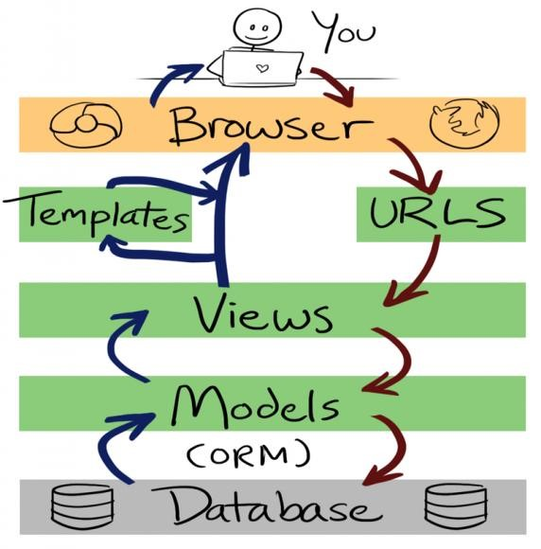

# 4.3 Django Installation

* **Virtual environment** 
  + - Before we install Django we will get you to install an extremely useful tool to help keep your coding environment tidy on your computer.
    - It's possible to skip this step, but it's highly recommended.
    - So, let's create a virtual environment (also called a *virtualenv*). Virtualenv will isolate your Python/Django setup on a per-project basis.
    - This means that any changes you make to one website won't affect any others you're also developing
    - All you need to do is find a directory in which you want to create the virtualenv;
    - For windows ,
    - To create a new virtualenv,you need to open the console and run C:\Python35\python –m venv myvenv.
    - It will look like this:
    - Command-line
    - C:\Users\Name\djangogirls> C:\Python35\python –m venv myvenv ▪ where C:\Python35\python is the directory in which python is installed and ‘myvenv’ is the name of your virtualenv.
    - **Working with virtualenv**
    - The command above will create a directory called ‘myvenv’ that contains our virtual environment.
    - Start your virtual environment by running :
    - Command line :
    - C:\Users\Name\djangogirls>myvenv\Scripts\activate
    - Now that you have your virtualenv started ,you can install Django.
    - Before we do that, we should make sure we have the latest version of pip, the software that we use to install Django.
    - In the console ,run pip install –upgrade pip. Then run pip install django~=1.9.0 or pip install django
* **Start The Project** 
  + - The first step is to start a new Django project.
    - Basically, this means that we'll run some scripts provided by Django that will create the skeleton of a Django project for us.
    - This is just a bunch of directories and files that we will use later.
    - On Windows (again, don't forget to add the period (or dot) ‘.’ at the end.
    - Command-line
    - (myvenv)C:\Users\Name\djangogirls>django-admin.py startproject mysite.
    - Here ‘django-admin.py’ is a script that will create the directories and files for you.
    - You should now have a directory structure which looks like this:

djangogirls |------manage.py |------mysite

settings.py urls.py

wsgi.py

__init__.py

* + - Here ‘manage.py’ is a script that helps with management of the site. With it we will be able (amongst other things) to start a web server on our computer without installing anything else.
    - The settings.py file contains the configuration of your website. ▪ urls.py file contains a list of patterns used by urlresolver.
* **Database Setup** 
  + There's a lot of different database software that can store data for your site. We'll use the default one, sqlite3.
  + This is already set up in this part of your mysite/settings.py file.
  + mysite/settings.py

DATABASES = {

'default': {

'ENGINE': 'django.db.backends.sqlite3',

'NAME': 'mydatabase',

}

}

* **For Postgres database :**

DATABASES = {

'default': {

'ENGINE': 'django.db.backends.postgresql_psycopg2',

'NAME': 'todo',

'USER': 'postgres',

'PASSWORD': 'admin',

'HOST': 'localhost',

'PORT': '5432',

}

}

* + = Model in database as a spreadsheet with columns(fields) and rows (data).
  + Creating an application
  + To create an application we need to run the following command in the console
  + (myvenv)~/djangogirls$ python manage.py startapp blog
  + You will notice that a new ‘blog’ directory is created and it contains a number of files now.
  + The directories and files in our project should look like this:

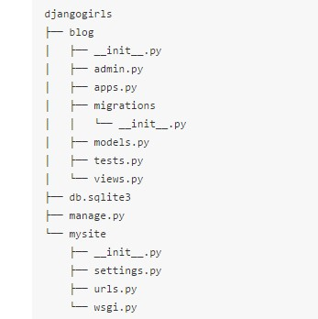

* + After creating an application, we also need to tell Django that it should use it. We do that in the file mysite/settings.py.
  + We need to find INSTALLED_APPS and add a line containing ‘blog’ just above ].
  + EG:
  + INSTALLED_APPS = [
  + 'django.contrib.admin',
  + 'django.contrib.auth',
  + 'django.contrib.contenttypes',
  + 'django.contrib.sessions',
  + 'django.contrib.messages',
  + 'django.contrib.staticfiles',
  + ‘blog’
  + ]
* **Creating Model** 
  + - Creating a blog post model:
    - In the blog/models.py file we define all objects called Models – this is a place in which we will define our blog post. ▪ blog/models.py
    - class Post(models.Model):
    - ……….
    - ……….
    - Create tables for models in your database
    - The last step here is to add our new model to our database.
    - First we have to make Django know that we have some changes in our model. (We have just created it!)
    - Go to your console window and type
    - python manage.py makemigrations blog
    - Django prepared a migration file for us that we now have to apply to our database. Type
    - python manage.py migrate blog

# Django Admin

* To add, edit and delete the posts we've just modeled, we will use Django admin.
* Let's open the blog/admin.py file and replace its contents with this:
* blog/admin.py
* from django.contrib import admin
* from .models import Post
* admin.site.register(Post)
* To log in, you need to create a *superuser* - a user account that has control over everything on the site. Go back to the command line, type ▪ python manage.py createsuperuser and press enter.
* (myvenv) ~/djangogirls$ python manage.py createsuperuser
* Username: admin
* Email address: admin@admin.com ▪ Password:
* Password (again):
* Superuser created successfully.

# GUI Programming

# Tkinter Programming

* Tkinter is the standard GUI library for Python.
* Python when combined with Tkinter provides a fast and easy way to create GUI applications.
* Tkinter provides a powerful object-oriented interface to the Tk GUI toolkit.

o **Creating a GUI application using Tkinter is an easy task. All you need to do is perform the following steps −**

* Import the *Tkinter* module.
* Create the GUI application main window.
* Add one or more of the above-mentioned widgets to the GUI application.
* Enter the main event loop to take action against each event triggered by the user.
* Tkinter provides various controls, such as buttons, labels and text boxes used in a GUI application. These controls are commonly called widgets.
* EG :
* Button,Canvas,Checkbutton,Entry,Frame,Label,Listbox,Menubutton,Menu etc… o **Some Important Methods**

CHAPTER 5 CODING

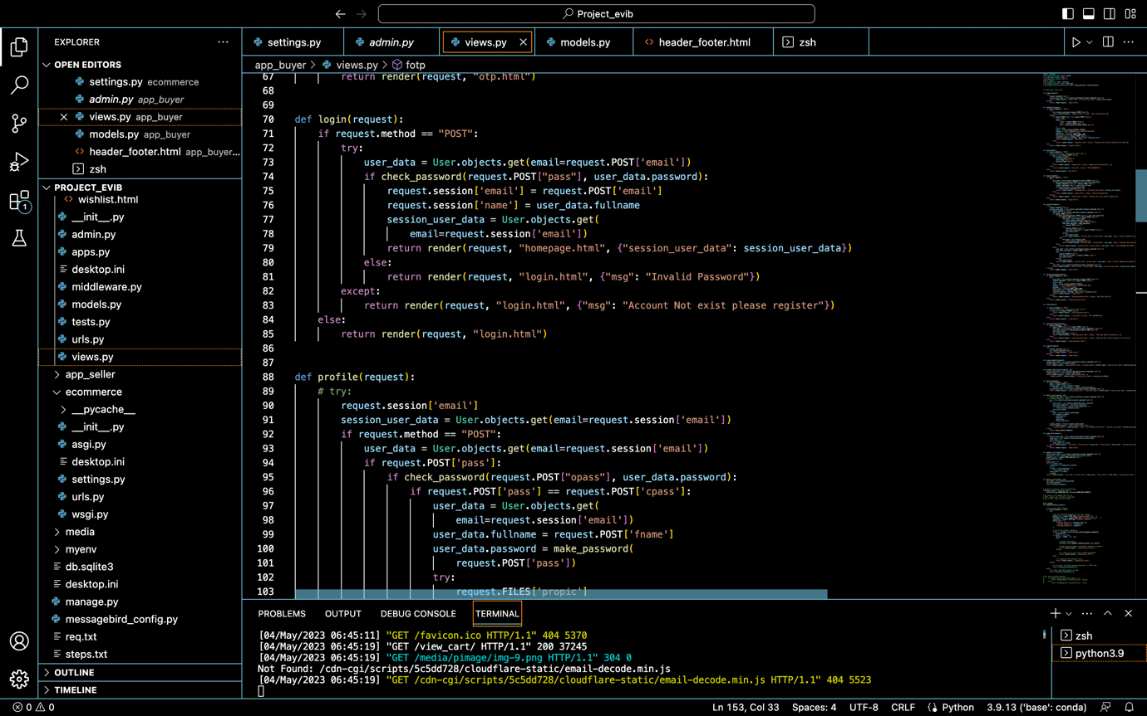

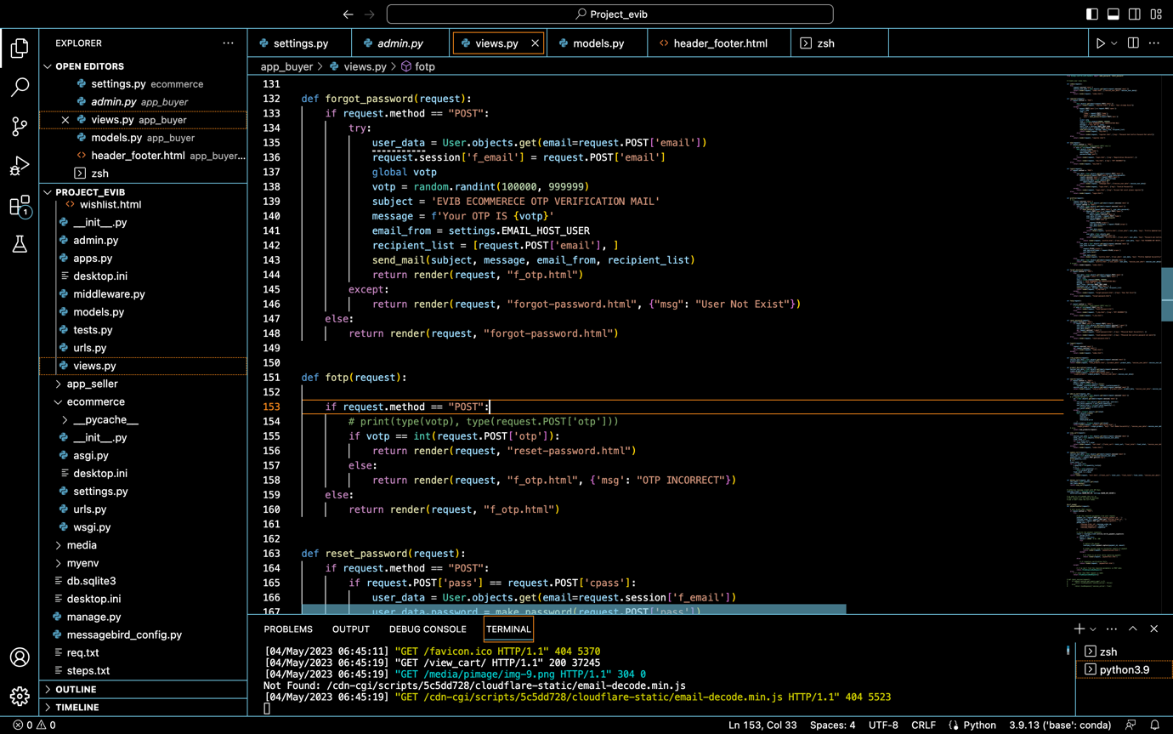

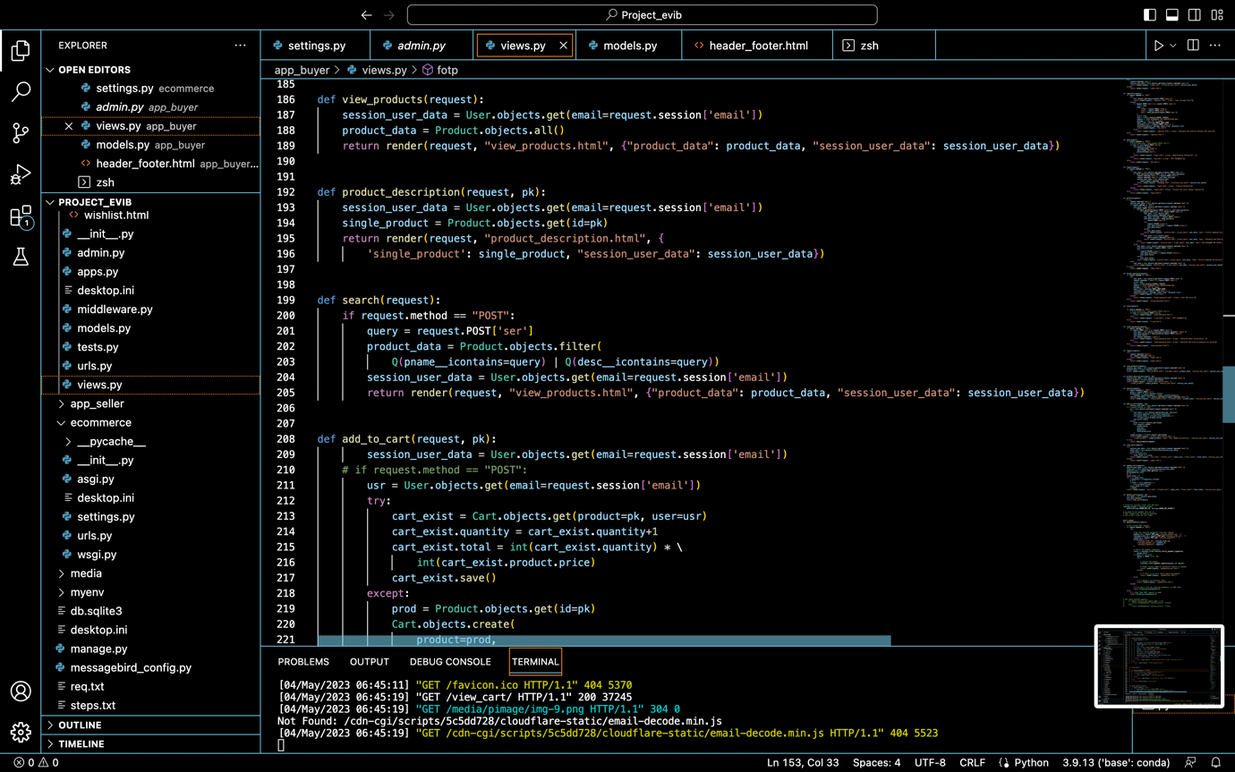

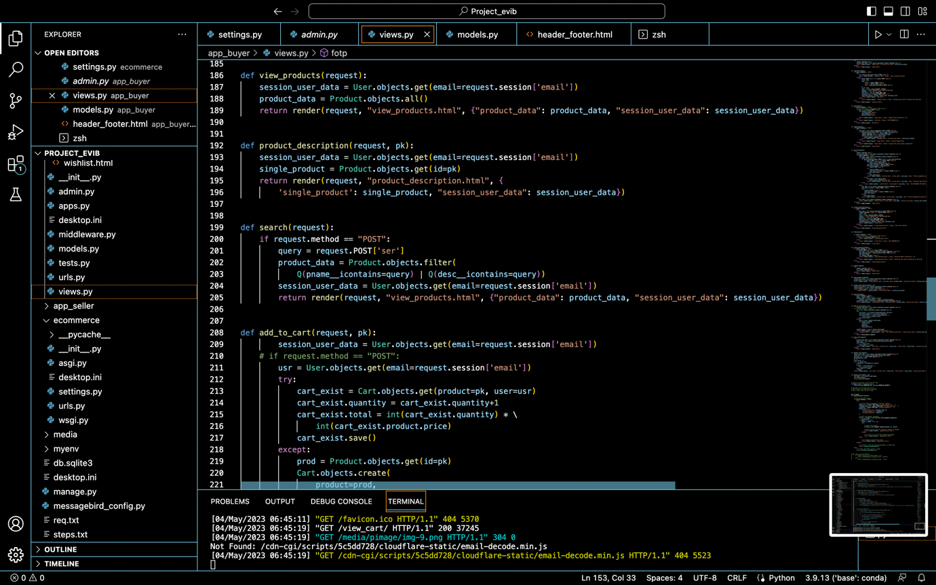

5.1 SCREENSHOT OF WEBSITE

PROFILE PAGE

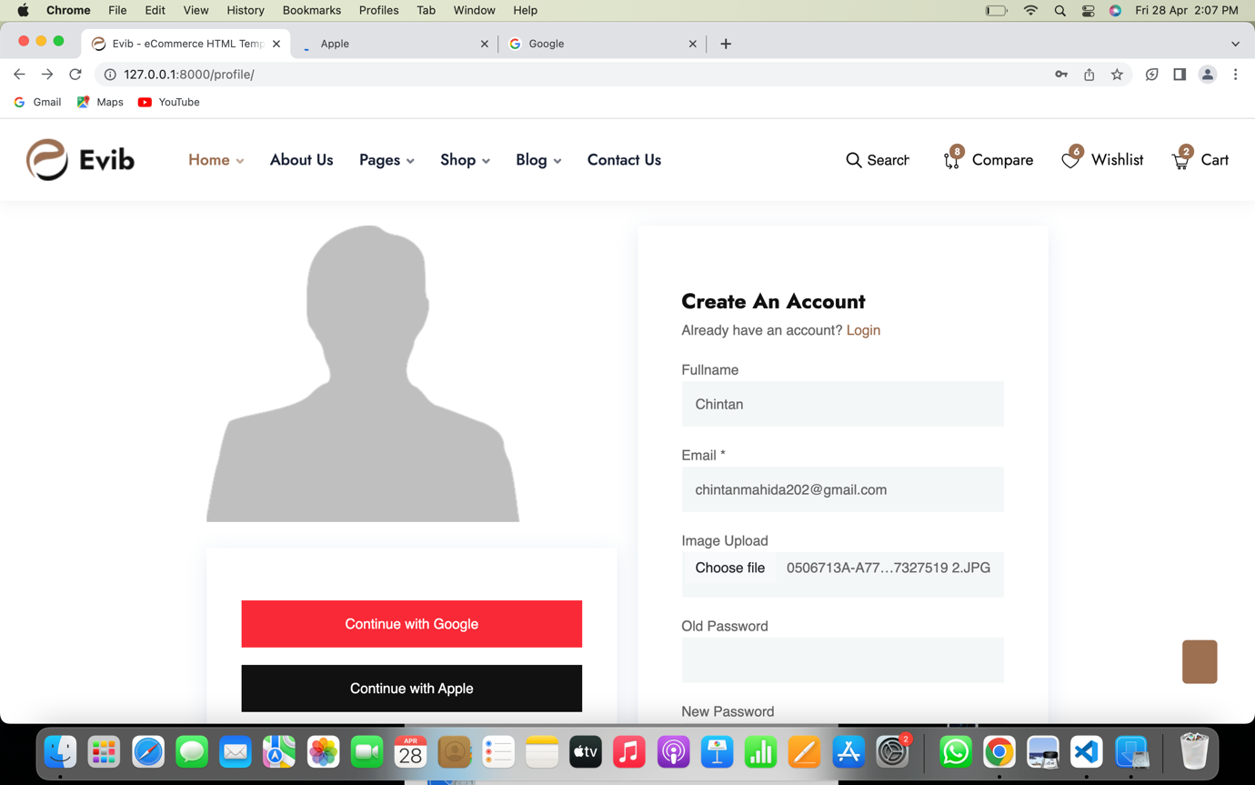

(Figure 5.1)

PRODUCTS PAGE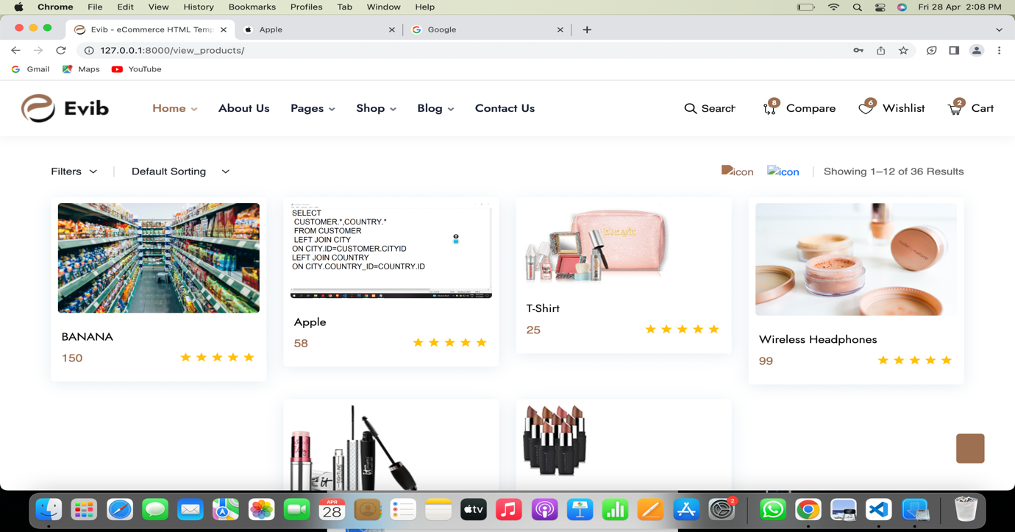

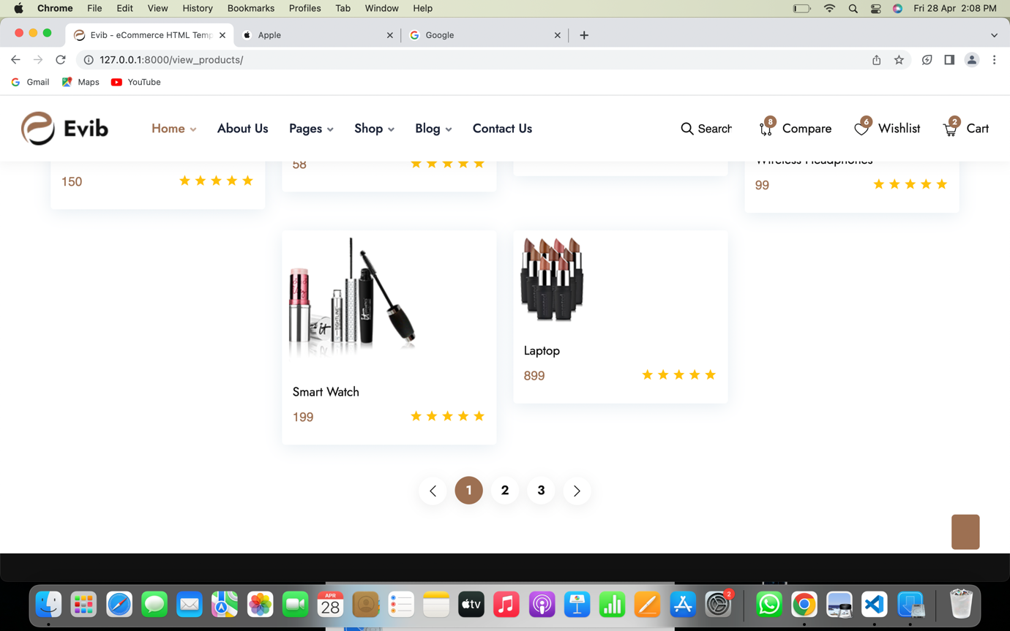

(Figure 5.2)

LOGIN PAGE

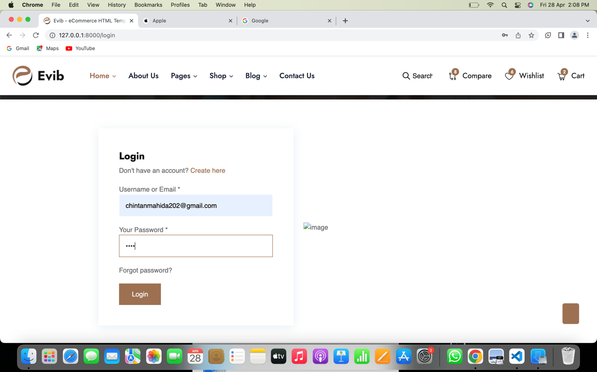

(Figure 5.3)

REGISTER PAGE

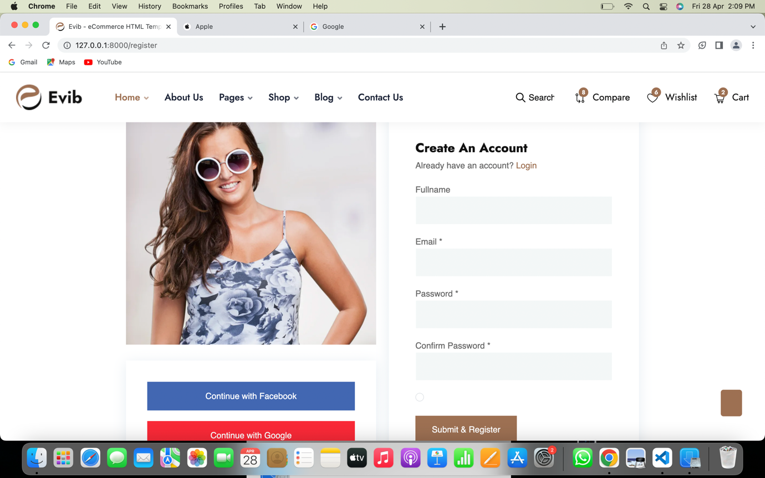

(Figure 5.4)

CART PAGE

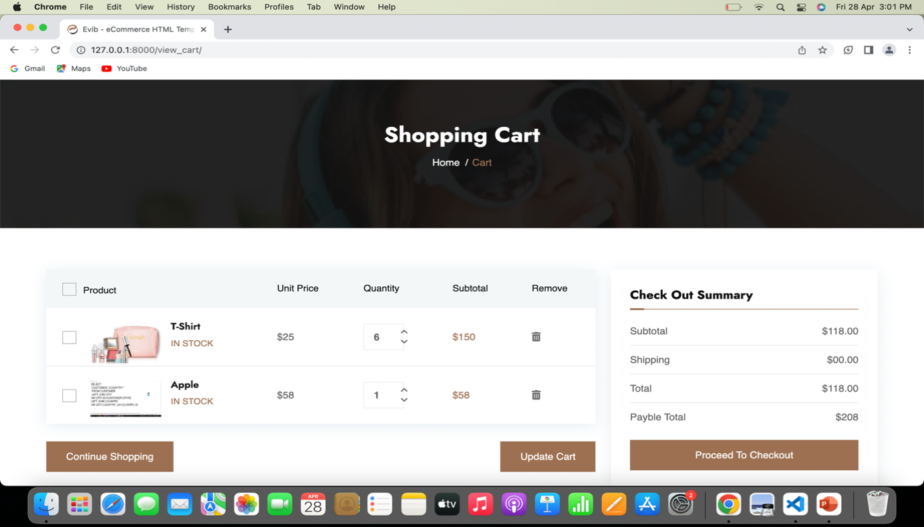

(Figure 5.5)

S

PAYMENT PAGE

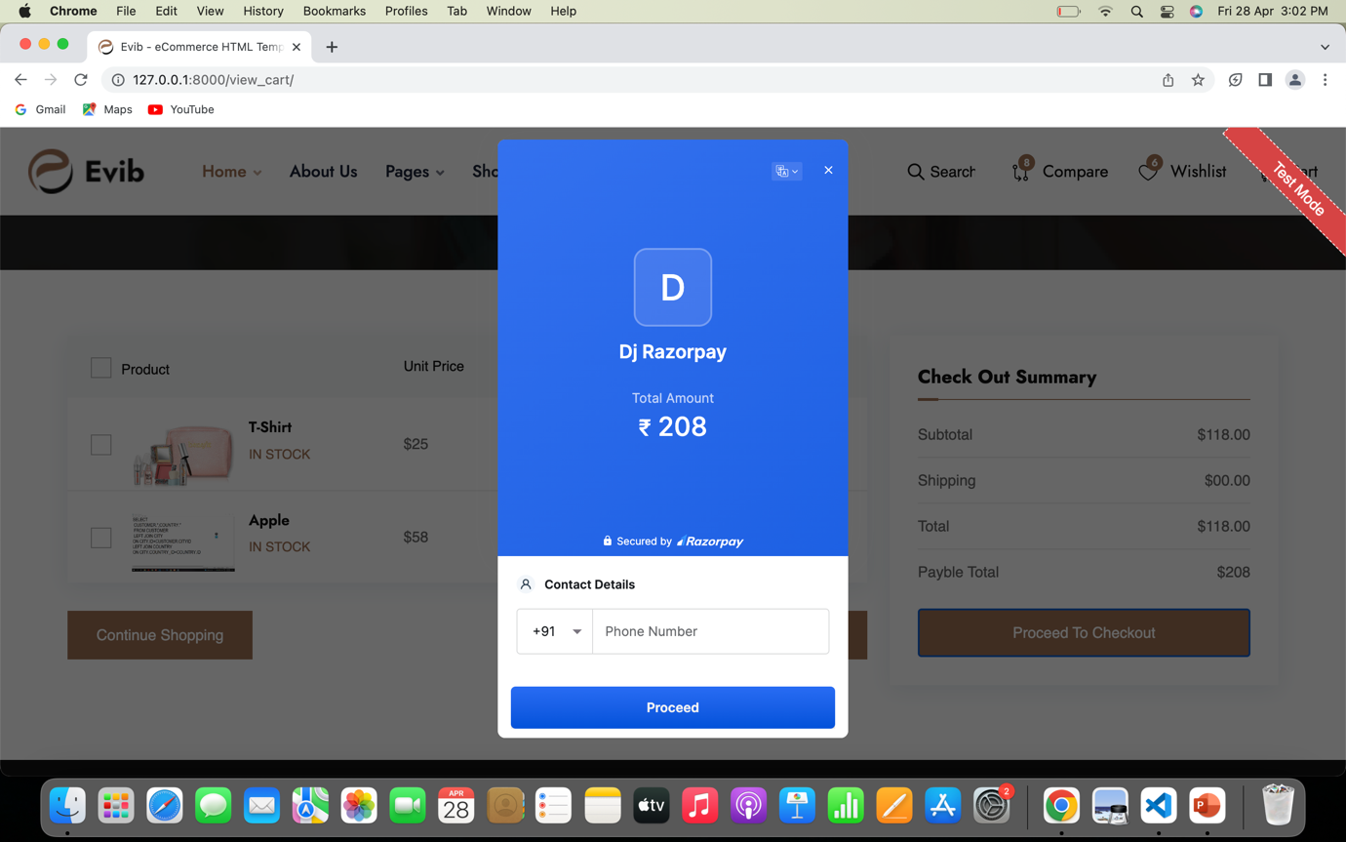

(Figure 5.6)

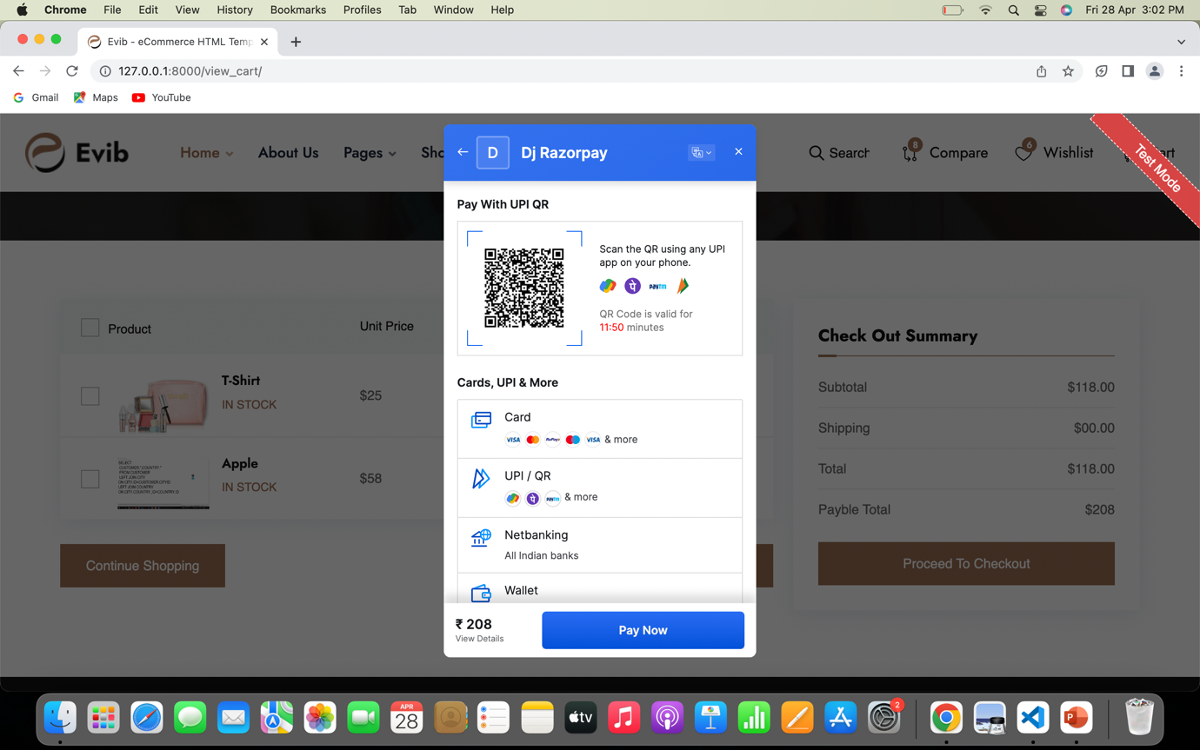

**CHAPTER 6 CONCLUSION**

I wanted to take a moment to express my sincere appreciation for the opportunity to work as a Web Developer Internship at Tops technologies. It has been an enriching and rewarding experience to be a part of the team and learn from some of the best professionals in the industry.

During my internship, I had the chance to work on several projects that have allowed me to hone my skills and knowledge of Web development. I also had the chance to work with a team of talented developers and designers, who have been instrumental in my growth as a developer.

I am grateful for the support, mentorship, and guidance that you and the team provided me throughout my internship. Your expertise and insights have been invaluable in helping me become a better developer. I will carry these learnings with me as I move forward in my career.